Creating your first Hello World App.

Start up Android Studio and select File-New Project

Choose an Empty Views Activity, Press Next

In the next window:

1. Choose Kotlin not Java
2. For the name, use your name with HelloWorld
3. For the Package name, verify that your company domain is unique. This is the directory where it is stored on your phone, so when you get to project submissions, your app won’t overwrite other people’s app on the same phone. Put your name in it somewhere to distinguish it from others in the class (Note: every student in the class needs a unique domain name)
4. Click on the folder icon for save location. Create a directory to store all your Android Studio Projects. You will need to know where your solution is to compress the whole project at the end for submission.
5. The language is Kotlin
6. Verify that the Phone and Tablet Minimum SDK is set to API 30

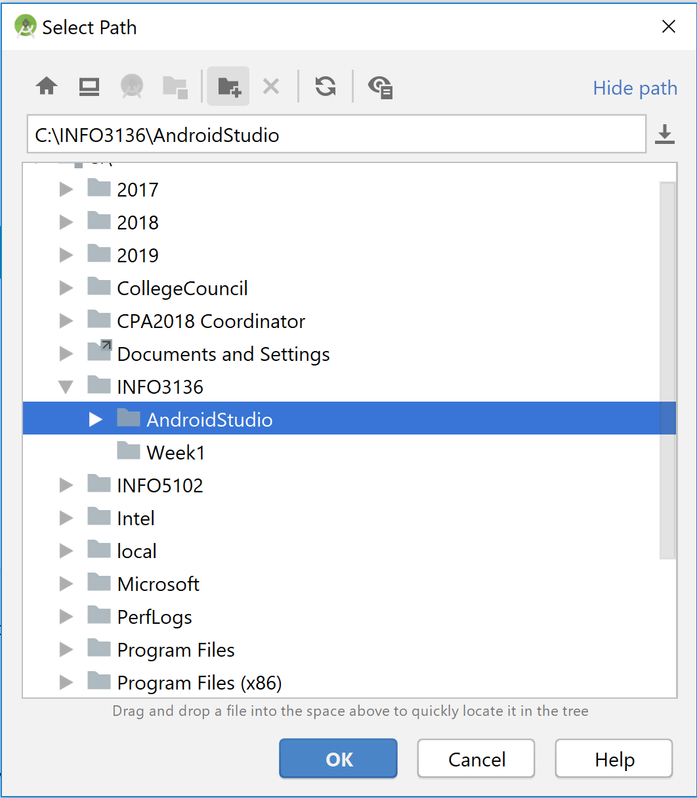

Press Finish.

You should see the window below. Android Studio will need to configure your gradle. Especially if this is your first program it will take a while. Watch the Gradle Sync window at the bottom to get an indication when configuration is complete.

Go to app-res-values-strings.xml and add a string to the string table. You need your full name in that new string. I called my string “hello_text”

In the solution, go to app-res-layout-activity_main.xml. This is what your start up window will look like. Note that the default layout is the Constraint Layout. This will allow the window and its widgets to be constrained to the size of the screen (important because devices come in all shapes and sizes).

Click on the TextView as shown (either in the component tree or the design window, the squiggly lines with the arrow shows that the text is constrained to all sides of the window. Click on the attributes tab to the right and go down to the Common Attributes –Text and click on the button to the right hand side.

The window below will appear. Choose the string that we just created, “hello_text”. Once you have done this, you will notice the Component Tree will show the TextView as “@string/hello_text”.

You may either run the program on your phone (hook it up through USB) or set up an emulator with Nougat that has the attribute using Google API’s. Google API’s are used for Google maps etc.

To install an emulator go to Tools – Android – AVD Manager and select Create Virtual Device. (Note: you should have gone through the Preparation Instructions that would have installed API 29 along with the Google API’s and emulators.) Here I have installed a Pixel 3 API 28 and shown running

Choose your phone or the appropriate emulator. (Note if you are using a phone, you will have to go to settings and Turn Developer options on and enable USB Debugging. When you plug in your phone, you will probably have to check the Enable USB debugging message.) Shown the Google Pixel API 34 is the emulator.

To take a snapshot of your phone screen go to the Logcat Window and press on the >> (shown below in red) then click on the camera (screen capture) icon to take a snapshot and press the record screen icon to take a movie of your device. This will allow you to take a screen captures and videos of your phone to submit.

